Sent to Jaim 10/14/2023 re: new FirstGlanceGIF that does PNG -> GIF.

I did 19 firstglancegif tests, various sizes, square, landscape,
portrait, rocking, spinning. All scale bars are the correct length:
same length as in a snapshot of the original view.
Tests included large sizes that firstglancegif automatically
reduces in size to avoid crashing due to ? out of memory errors?.
Snow is gone! :)
Those are the two big improvements.
Problem #1 remains that with small sizes (<~350 pixels square),
the fonts get very tiny. I will alert users if they try to make
smaller animations. I will recommend at least 400 pixels.

Here is a test with 263 x 200. 263 pixels is the smallest width Firefox allows.
Original left, snapshot of animation right.
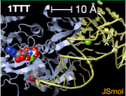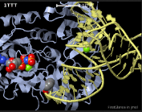
Here is a test at 400 pixels square. 500 pixels is also good,
and the largest square the server can handle (larger
requests are automatically reduced by firstglancegif).
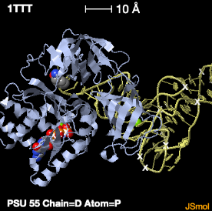 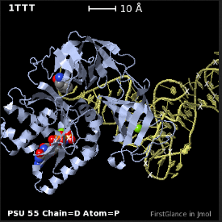
Problem #2 is that when the scale bar is longer than about 15%
of the width of the image, although it is 10 Å in the original view,
it becomes 1 Å in the animation. The length is correct, but a 1Å bar
is too short to be useful when 10 Å is only 25% of the image width.
Example: 400 pixels again, but with higher zoom.
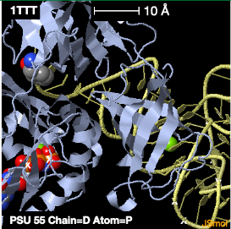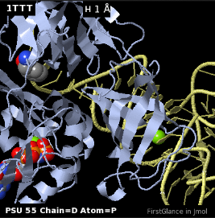
I can live with problems #1 and #2.
It is great to have a correct scale bar and no snow!
Thanks so much Jaim. -Eric

